**Instruction for how to Run the Program**

This is a general step Instruction, if you want to run the program by yourself now (What needs to be mentioned is the whole program is designed by running together, we can’t run it in a seperate way)

But I already made a Datahub wrapper doc for our project, if it goes well, we can run the program all by ourselevs without doing the step 2.

if you just want to add some tests instead of running the program before we get the wrapper from DataHub, just open the file perform_test.m. (you can just go to the yellow highlight part below)

***1.*** Make sure all the files are in the same folder. You can download the files in our github page. And the code is in the datasets/synthetic/Latest_Code.

2.Download the subgraph searching software. You can download the zip file in our github page as well which is in GtrieScanner(Software)

***2.1***

For everyone, before you can run the program sucessfully you need to make some modifications by yourself:

Open the file Random_Flow_Sampler.m in line 334, 335.

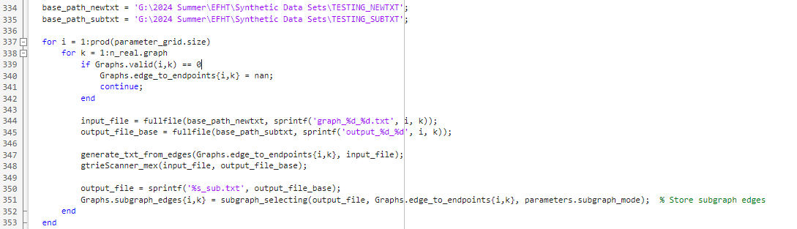

The base_path_newtxt is the path where the new graph’s edge to endpoints txt filw will be genereated

The base_path_subtxt is the path where the output files after the software runnig will be generated.

Change these two path based on your own laptop.

***2.2***

Then go to the line 348

This is a function I made to run the external software(cuz it needs to run the command

“the path where the software at/gtrieScanner -s 4 -g input_file -u -o output_file_base.txt -oc output_file_base_sub.txt -f simple.”

Please try to make a simlar function which is looks like:

function run_external_program(input_file, output_file_base)

Calling the command in your laptop

“the path where the software at/gtrieScanner -s 4 -g input_file -u -o output_file_base.txt -oc output_file_base_sub.txt -f simple.”

End

The reason why I create the gtrieScanner_mex file is because the command cant be run directly in this way at my Windows System laptop. But I’m not sure if the command can be run directly in MacOS. Please try it, cuz unfortunately I don’t have a macbook...

3.Then run the file the Flow_Examples.m

So basically, once you figure out the step 2, every time u can just do step 3 to run the whole program.

And the file Flow_Examples.m. It contains all parameters that needed for the graph and flow generation. I already put some options in it. So basically we can change parameters, graph distributions, flow distributions, test choices, subgraph types in this file.

The other thing you can do is to add test which is in the file perform_test.m. I added five different test. (one is just for quick program debug, I already wrote a description in the file). For adding more tests, u just need to make sure to use (flow_data, subgraph_edges). Or u can send me the test u’ve designed by using other programing languages, I can transform and add it into the file.

Please go to the readme.txt file in our github page for other files detailed descriptions.

Please let me know if there is something I made you confused or some problems you cant figure out !